28 May 2015

STAHL CraneSystems GmbH
Daimlerstraße 6
74653 Künzelsau

Your contact for questions on the content: Author:
Heike Metzger Dipl.-Ing. Jan Türk
Tel. +49 7940 128-2388 VISUELL Studio für Kommunikation
Fax +49 7940 128-2300 Tel. +49 711 64868-0
heike.metzger@stahlcranes.com jan.tuerk@visuell.de
www.stahlcranes.com

High waves in the research institute
Customised crane builds test dykes for wave research station in Delft

4.5 m high waves roll along the nearly 300 m long flume. Towering water masses, set in motion by the largest wave machine in the world. A raging storm, conjured up by humans, but without wind or rain. The surf thunders onto the dyke built in the flume. Will it hold? What forces act and where? Can stability be improved further by a different sand or stone composition? Deltares measures, analyses and uses its findings to advise coastal states all over the world on protecting themselves from natural catastrophes and flooding. The Dutch research institute is at present constructing a new wave flume in Delft, to enable dykes and breakwaters to be tested in realistic conditions with the aid of artificial waves. Not only the flume itself, but also the gantry crane needed for the facility, is a spectacular purpose-built design. STAHL CraneSystems’ Dutch crane building partner, CraneBuilders, commissioned the customised crane in autumn 2014. The research facility is to be inaugurated in summer 2015.

Deltares uses a specially designed gantry crane, travelling over the whole length of the basin, to construct the test dykes. One of its functions is to position sand and stones accurately in the flume using a grab. The crane operator has a clear view of everything all the time from his mobile cabin: the load area of the lorry next to the basin as well as the bed of the flume around 20 m below. Constructing test dykes demands fast, accurate work. STAHL CraneSystems designed an off-standard grab wire rope hoist as SH 6 twin drive concept especially for this purpose: this wire rope hoist provides the required hoisting speed of up to 25 m/min with two rope drums and two hoist motors. A reeving system newly developed by STAHL CraneSystems, in which the compensating sheave is situated not between, but in a horizontal position alongside the wire rope hoists, enabled the headroom to be reduced by 30 % compared with a standard wire rope hoist. Being operated by two hoists also permits controlled, steady movements of the grab shovel.
A second wire rope hoist, also on the inside of the portal crane, is used to lift smaller construction vehicles onto the bed of the flume. Both wire rope hoists can be coupled for tandem operation and operated in synch by means of remote control. This is necessary for positioning the 20 tonne steel partition wall when the basin needs to be shortened for certain trials.

Unusual design
For this project, both hoists needed a high classification (FEM 3m) although “only” safe working loads of 12.5 t were required. This specification for the auxiliary hoist combined with a monorail trolley and the lifting height needed could not be met with a standard hoist. For this reason CraneBuilders chose an AS 7 wire rope hoist and had STAHL CraneSystems design a customised monorail trolley so that the wire rope hoist now combines compact dimensions with a high classification.

Custom-built gantry crane
CraneBuilders’ skills were demonstrated in the dimensional calculations: the gantry had to pass through the maintenance shop doors, however also had to be high enough for the laboratory container, travelling along two internal rails independent of the crane during tests, to move underneath it.

Well-designed
The crane has over 5 m long jibs for hoists and crane cab on one side of the gantry so as to be able to take up bulk material and loads parallel to the flume. A heavy counterweight on the opposite side of the gantry crane prevents it tipping when heavy loads are lifted on the jib.

Safe passenger transportation
Deltares’ scientists position sensors in the dyke to measure the effect of the waves. They can travel down into the flume in a power climber lifting platform mounted on the crane and easily reach the various position heights required. Sensors on the bottom of the cage automatically halt the lowering procedure if it touches the water. A safety circuit avoids collisions with the laboratory container travelling beneath the crane and prevents the hoists and lifting platform being operated simultaneously. The power supply to the crane gantry and the laboratory container was designed as a festoon cable system at a height of 4 m to prevent measurement errors by the sensitive sensors.

Frugal giant
All travel and hoist motors of the gantry crane are frequency-controlled and can be operated precisely. The crane control designed by CraneBuilders feeds the energy generated by frequency inverters and brakes back into the grid and thus helps minimise the total energy consumption of the crane system.

At the service of science
Building dykes is a challenge: gradient, material composition and distance from the sea must be precisely calculated, simulated and tested. As a nation 26 percent of whose surface area is below sea level, the Dutch are real experts in the field of dyke construction. Threatened by climate warming and rising sea levels, the country invests great sums in coastal and dyke research. What forces do waves exert on dykes and how can the 400 km long Dutch coast be protected in the long run? The new test flume is expected to provide new insights. CraneBuilders and STAHL CraneSystems are proud of the fact that their gantry crane will assist Deltares in its important research work.
Photo material (lead and detail photos):

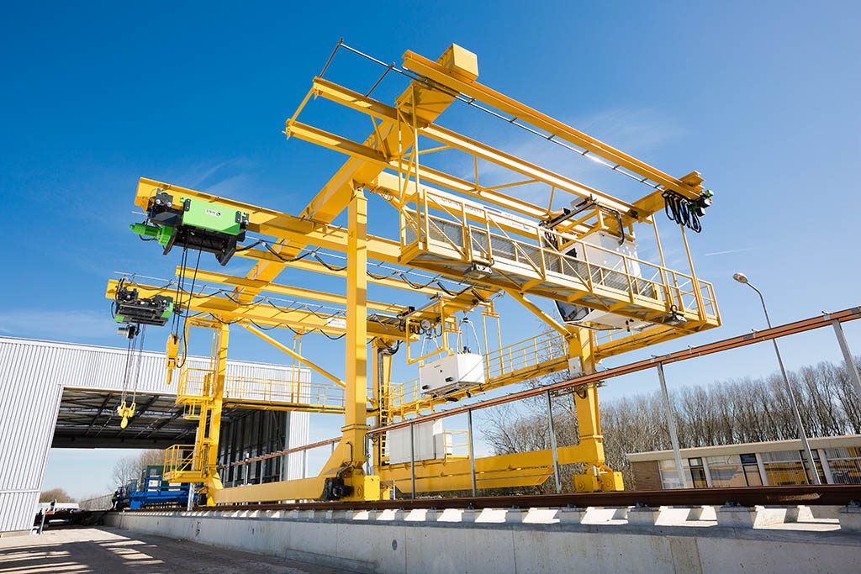 | High-tech gantry crane for cutting-edge research in the Netherlands. CraneBuilders’ solution is more than remarkable.
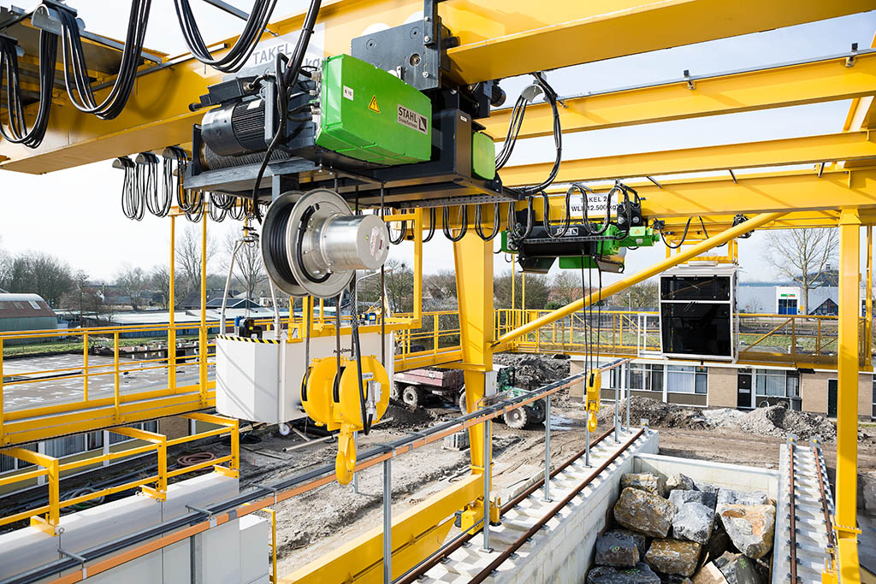 | This wire rope hoist has been developed to assist the scientists building the test dykes with its fast, precise lifting movements.
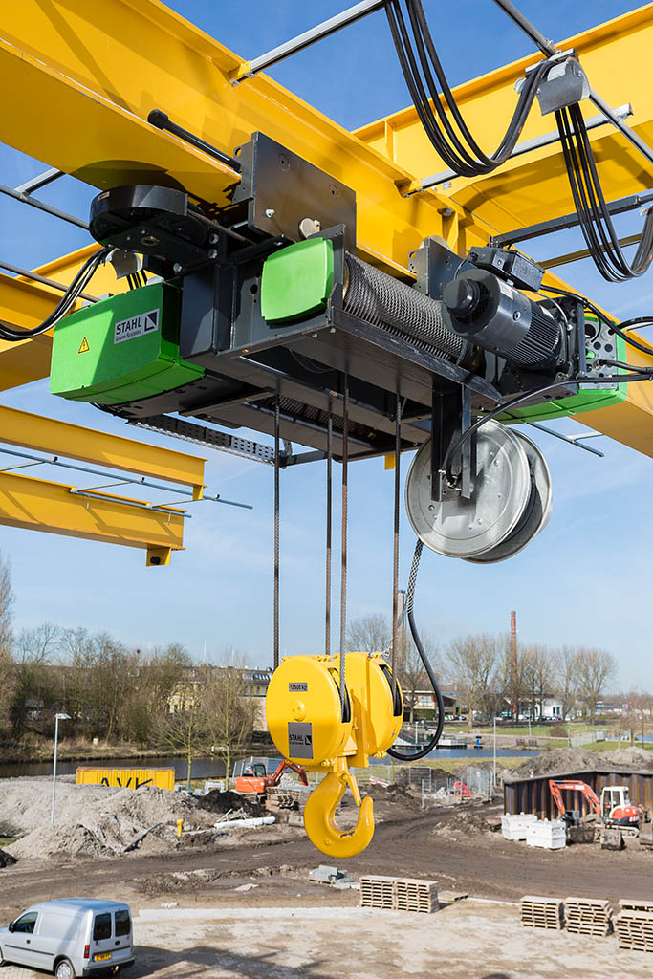 | The SH wire rope hoist as TwinDrive concept combines the high FEM 3m classification with hoisting speeds of up to 25 m/min and a very low headroom. The guide roller is positioned horizontally next to the hoist (top left in the photo).
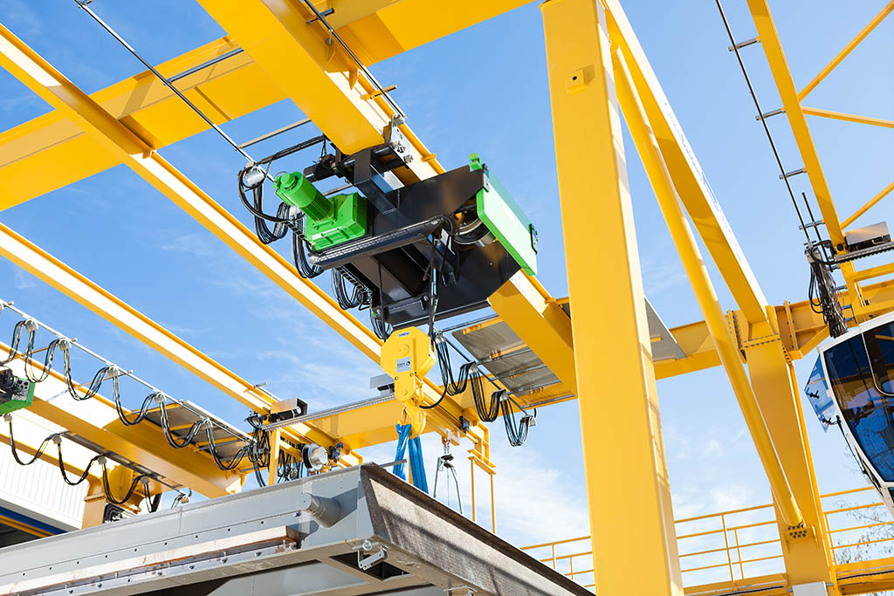 | The compact AS 7 wire rope hoist with monorail trolley acts as a powerful auxiliary hoist.
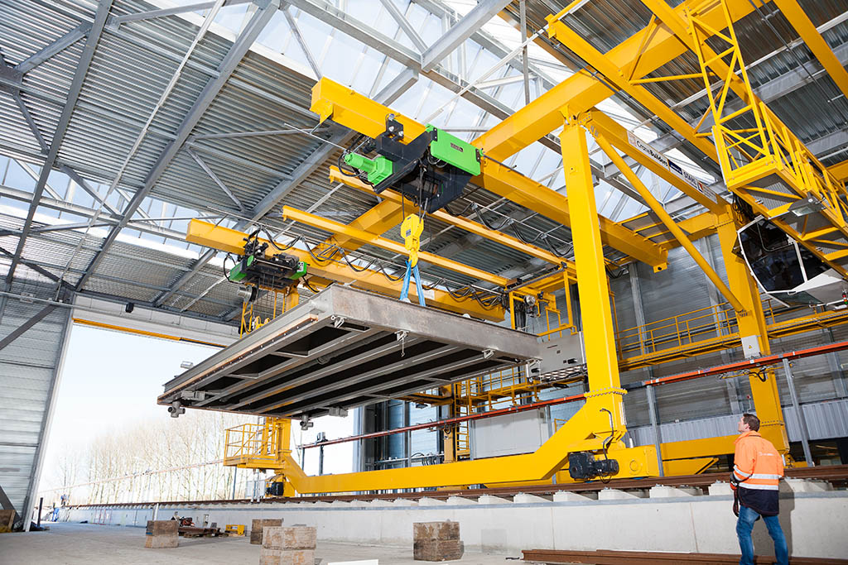 | The wire rope hoists can be coupled for tandem operation, for example to lift the partition wall for shortening the flume. Lateral jibs enable loads to be taken up outside the gantry crane.
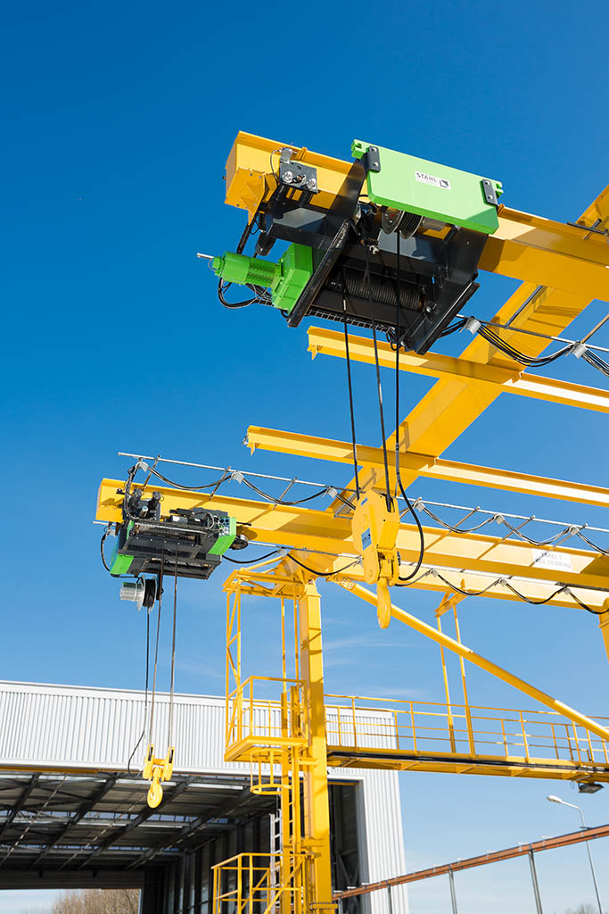 | You won’t find these wire rope hoists in any catalogue: STAHL CraneSystems developed the customised hoists to meet the requirements of CraneBuilders and Deltares.
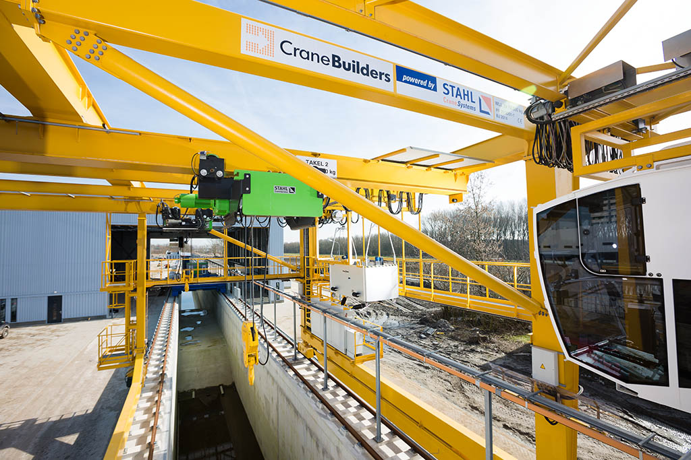 | The crane operator has his eye on everything all the time from his mobile cab: the load area of the lorry next to the basin as well as the bed of the flume.

