17 April 2017

STAHL CraneSystems GmbH
Daimlerstraße 6
74653 Künzelsau

Your contact for questions on the content: Author:
Heike Metzger Clara Ketterer
Tel. +49 7940 128-2388 VISUELL Studio für Kommunikation
Fax +49 7940 128-2300 Tel. +49 711 64868-0
heike.metzger@stahlcranes.com clara.ketterer@visuell.de
www.stahlcranes.com

Turning one into three
A powerful crane on its travels

In autumn 2015, the certified partner of STAHL CraneSystems, Stahl Cranes & Hoists, based in Johannesburg, South Africa, received a special order: A two beam bridge crane fitted with STAHL CraneSystems equipment was to be manufactured in Johannesburg and then transported by land and sea to Ghana, more than 10,000 km away. As so often, a carefully conceived special option had to be developed in order to make this project possible.

The order from Orsam Oil and Gas South Africa (Ortec) reached Stahl Cranes & Hoists in October 2015. A two-beam bridge crane with a total lifting capacity of 75 tonnes was to be supplied to the General Electric work in Ghana. STAHL CraneSystems produced an AS 7 wire rope hoist for it at its Künzelsau plant, and an SH wire rope hoist as an auxiliary hoist. The crane components for the project such as the controls and drives were also delivered to Johannesburg by STAHL CraneSystems. Here, Stahl Cranes & Hoists completed and assembled the two-beam bridge crane.

But how could such a massive crane make the long journey from Johannesburg in the south to Ghana in the western part of the continent? Working with engineers from STAHL CraneSystems, the team at Stahl Cranes & Hoists developed a unique, ingenious beam construction made up of three individual parts. In this way, after it had been successfully assembled in the plant in Johannesburg, the crane was dismantled and packed into two containers around 12 m long. These were transported 600 km by land to Africa’s largest container docks in Durban. From there, the crane was shipped by sea to Ghana, over 9,000 km away.
To keep to the project’s tight schedule, the Stahl Cranes & Hoists technical team, led by Site Quality Manager Theunis van Schalkwyk, also travelled to Ghana. The engineers were supported by the expert staff of Orsam Oil and Gas, who were actively involved in the work until completion of the project on the site of the end customer, General Electric. Together, they re-assembled, installed and commissioned the crane.
When carrying out the load testing, the team had to battle a few challenges. Ghana has been in an energy crisis for four years, and the country even has problems with running water at times. Water initially had to be delivered by tanker to fill the BigBags, but these could not achieve the necessary reliable water pressure. This meant that testing the SMC and SLE output devices was more difficult. The oppressive weather conditions and the rough terrain also impeded progress. However, after a few days of diligent work and eager dedication, all the tests had been successfully completed and the crane system was taken into operation on time.

The project was made possible by good communication and team work between STAHL CraneSystems, its partner Stahl Cranes & Hoists, Ortec South Africa and Ortec Ghana. We would like to thank everyone involved!

With the kind support of Steve Claase, Stahl Cranes & Hoists.

2.879 letters

Graphical material (Lead- and detailpictures):

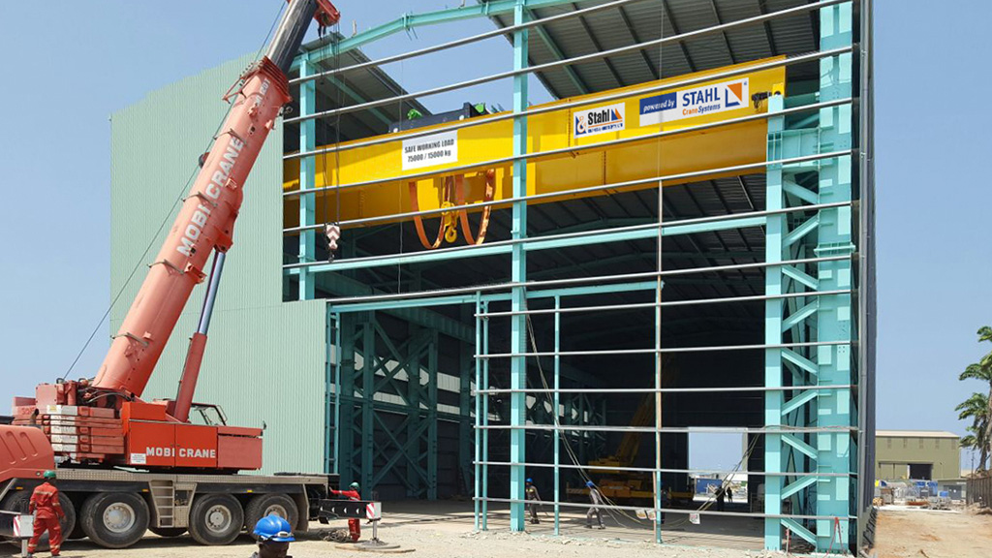 | An intercontinental project: the crane system from Stahl Cranes & Hoists from South Africa was erected in General Electric’s new plant in Ghana with the technology of STAHL CraneSystems from Künzelsau.
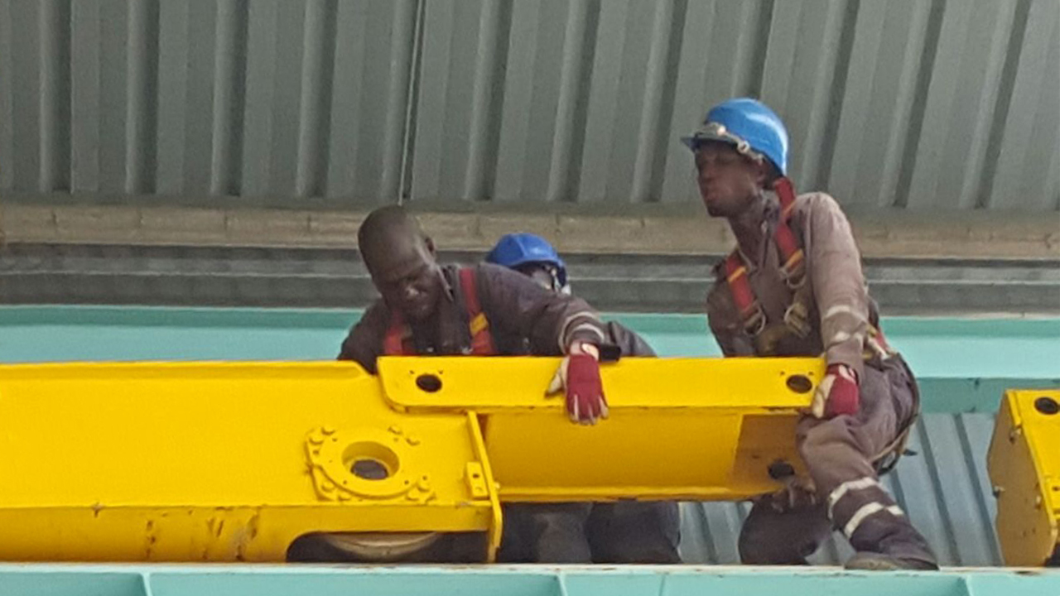 | The three individual parts of the crane are put together by a team of experts.
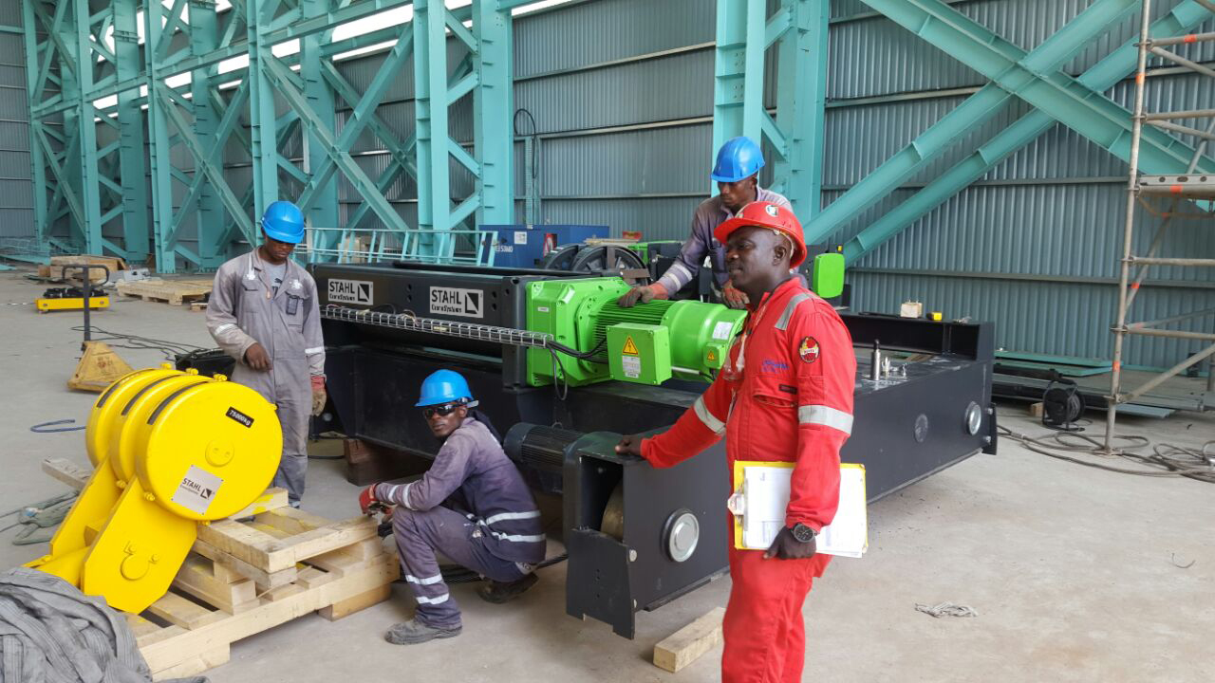 | The crane technology manufactured in Künzelsau (AS 7 wire rope hoist and SH wire rope hoist as auxiliary hoist) arrives at General Electric’s plant in Ghana.
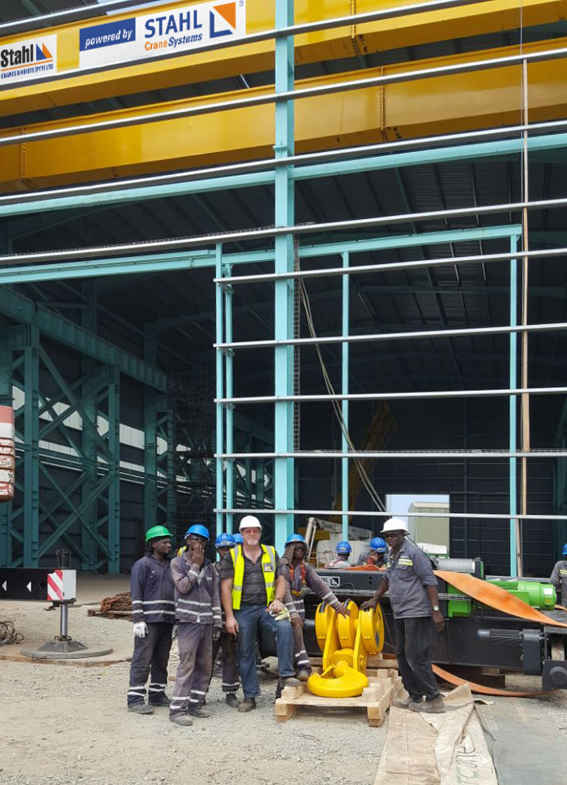 | The large-scale project was supported by a team, whose untiring effort enabled the successful refurbishment of the crane.
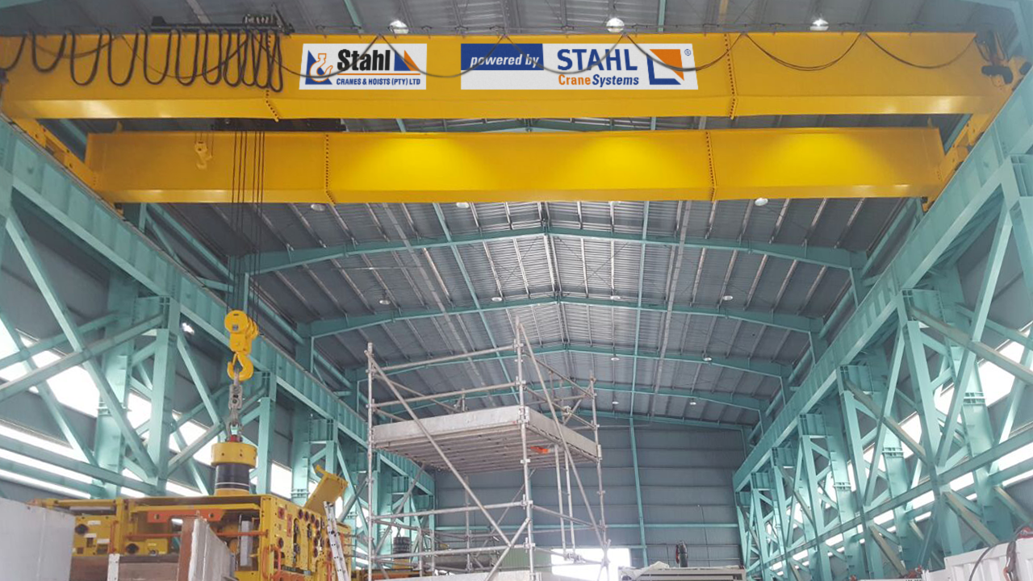 | It is difficult to believe that the crane with a span of 24 metres was only put together out of three parts at its installation site.
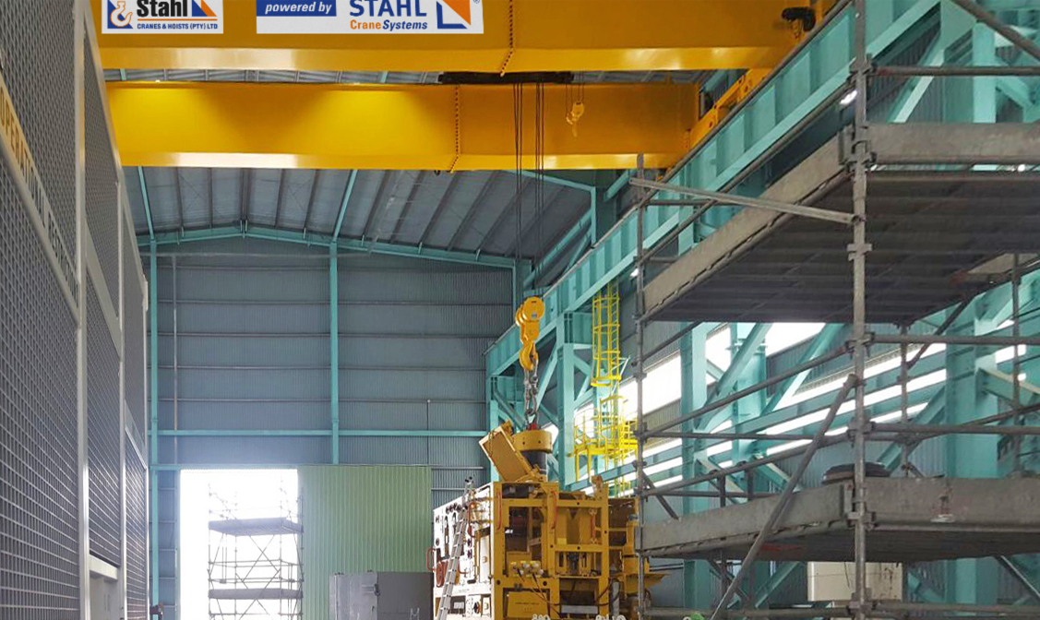
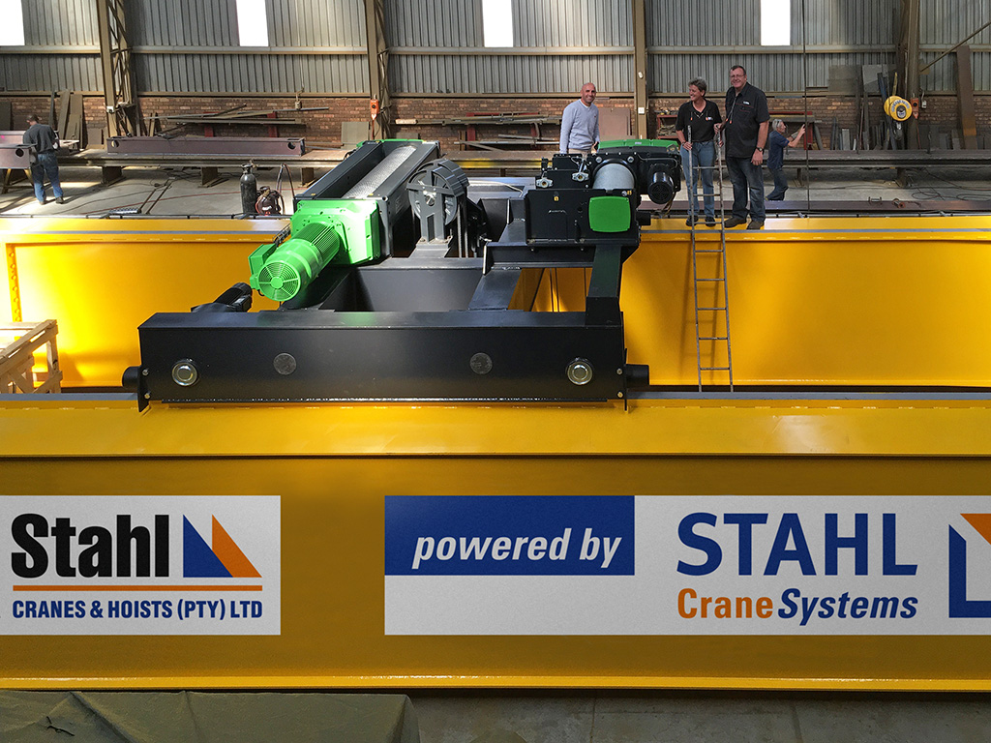 | The crane technology from STAHL CraneSystems was first mounted on the beams manufactured by the crane builders Stahl Cranes & Hoist and then tested and shipped to Ghana.
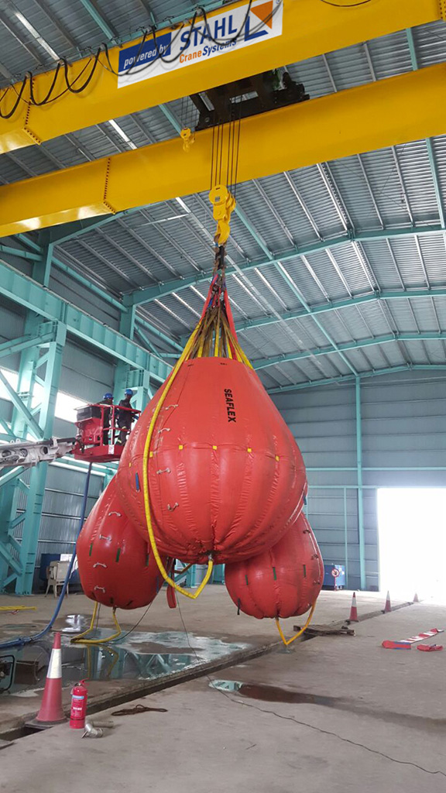 | BigBags filled with water were suspended from the crane for the load test.
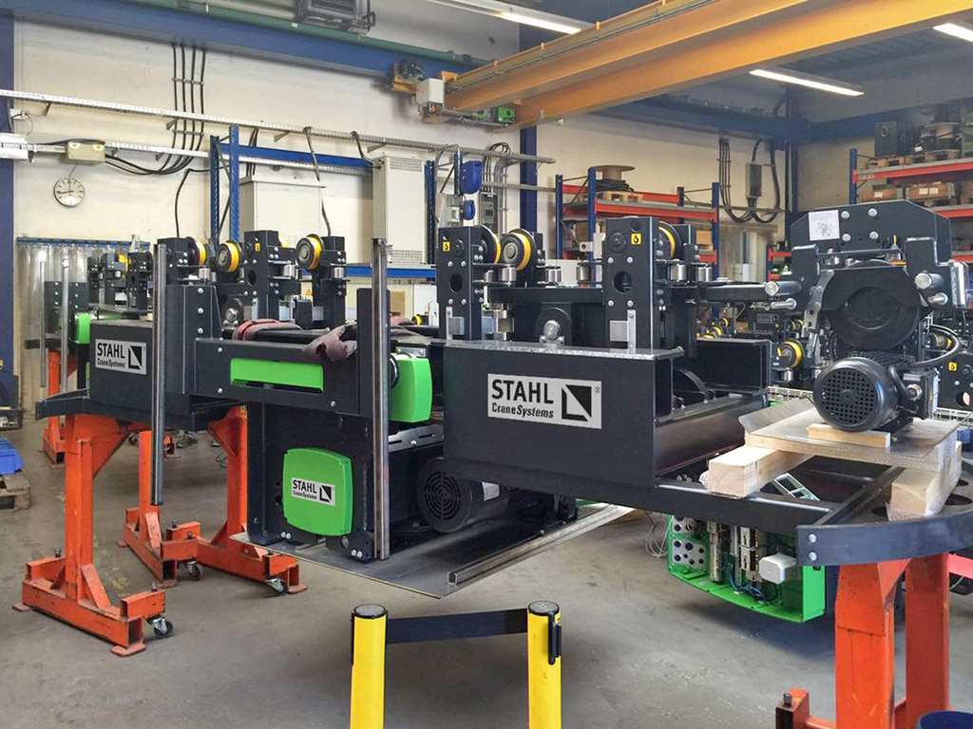 | The AS 7 wire rope hoist and SH auxiliary hoist are manufactured in Künzelsau before the long journey to South Africa.

